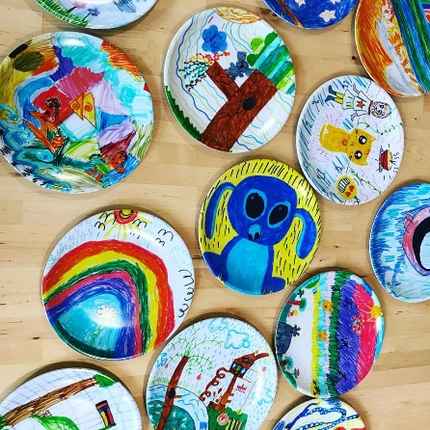
Underbool Primary School- Picture Products Fundraiser
Have you ever wanted to create a special keepsake for your child, grandparent or someone special? Well we are holding a fundraiser with Picture Products to allow your child/children to create a special gift that they could cherish & look back on in years to come. Or allowing them to create a special gift for Father’s Day? Look no further!
Products that can be made, please indicate below how many templates you require to be sent home:
- Picture Plate $25 – most popular x _______
- Tablemat $20 x _______
- 2019 Calendar $15 x _______
- Picture Clock $30 x _______
- Small Clock $25 x _______
- 600ml Water bottle $25 x _______
- Mug $20 x _______
- 400ml Water Bottle $20 x _______
- Phone Case $20 x _______
Name of child/family ______________________________
Please return this form to the school as soon as possible so that we can provide you with the templates to start creating!
If you would like to check out the products & what is offered head to their website to find out more www.pictureproducts.com.au
We require all beautiful pieces of artwork & payment to have been made & into the school no later than 27th June. This will allow enough time for the products to be made & returned just in time for Fathers Day. Please note: If payment is not received by 27th June we will not be able to send your template in with the bulk batch & a postage and handling fee will be added to your late order if you wish to proceed.

